МУИС-ийн Эрдэм шинжилгээний бичиг № 14 (548)

ХӨДӨЛМӨРИЙН ХАРИЛЦААНЫ СИСТЕМ ДЭХ ЗАСГИЙН ГАЗРЫН ОРОЛЦОО: ХАРЬЦУУЛСАН ШИНЖИЛГЭЭ /БНХАУ, АНУ-ЫН ЖИШЭЭН ДЭЭР/

Ш.Оюунханд доктор профессор МУИС-ийн Социологи, Нийгмийн ажлын тэнхим
З.Оюунзаяа Австралиийн Сиднейн CQU-Их сургуулийн бизнесийн менежментийн магистрант

Хураангуй: ЭШ-ний эл өгүүлэлд БНХАУ болон АНУ-ын хөдөлмөрийн харилцааны системийн онцлог дахь засгийн газрын нөлөөлөл болон оролцоог капитализм, үйлдвэрчний эвлэл, COVID-19 цар тахлын нөхцөл байдал зэрэг хүчин зүйлүүдтэй холбон харьцуулсан шинжилсэн болно.
Өгүүллийн эхний хэсэгт дээрх улсууд дахь “капитализмын” хувилбарууд, нөхцөл байдлыг тайлбарлаж энэ нь эвлэлдэн нэгдэх, нягтрах үйл явцыг хэрхэн нөхцөлдүүлж буйг, харин төгсгөл хэсэгт Ковид-19 цар тахлын нөлөө, түүнд үзүүлж буй хариу үйлдлүүдийг харьцуулан шинжлэн дүгнэсэн болно.

Түлхүүр үгс: Хөдөлмөрийн харилцаа, ажил олгогч, капитализм, ковид, хүн капитал

Introduction
Every nation has its employment relation system to have a balanced and efficient structured work force. Due to unemployment has influenced the nation’s economic growth negatively, it is vital to create satisfaction for the parties in employment relation. (Mohseni and Jouzaryan, 2016) China is one of the leading nations in terms of human capital which is able to be an influential factor in the world’s employment relations. Also, the United States is one of the G7 countries with the largest and advanced economies in the world. Therefore, this paper will compare and contrast China and the United States employment relation system in terms of varieties of Capitalism, unionization, and the recent situation COVID-19. The first part will explain both countries’ varieties of capitalism followed by unionization and its density, and then the essay will describe the impact and reaction of the Corona Virus.

Varieties of Capitalism
A variety of Capitalism framework is depending on whether the country is following firm-centered, government-centered, state-centered approaches. (Feldmann, 2019) Soskice and Hall (2011) distinguish two major systems of economy liberal market economies (LME) and coordinated market economies (CME) that cite the legal system, market, and employer organizations. (Soskice and Hall, 2011 as cited in Dibben and Williams, 2012) Moreoever, Godard (2002) noted that the role of the state has a central influence on employment relations. (Godard, 2002 as cited in Dibben and Williams, 2012) The United States gross domestic product (GDP) annual growth rate is around 5% in the last five years, however, due to the COVID-19 in the first quarter of 2020 GDP’s annual growth rate is decreased to 1% and in the second quarter, it falls into -7%. (The United States, GDP Annual growth rate, https://tradingeconomics.com/) In the U.S Bureau of labor statistics, the immigrants consist of 26% overall United States’ workforce in 2016. (Bernstein et al., 2018) Bamber (2016) noted that the United States can be seen as the archetypal liberal market economy. It is because of the labor market diversity and the key role of employers in the employment relation system of the United States. Also, Bernstein et al., (2018) demonstrated that immigrants play a key role in innovation that 23% of immigrants are innovators while U.S innovators remaining 16%. In liberal market economies, institutions take an arm’s length approach to regulating the economy and the state is liberal. (Mariotti and Marzano, 2019) Liberalism gives freedom in the production of products and services and allows people to act freely in the market. (Meyer, 2020) Countries of liberal market economies, especially the United States, features a market driven financial

system, generalist education, and training system, low levels of network among firms, flexible use of external labor markets, top-down decision-making structures inside firms. (Witt and Jackson, 2016)
Hou et al., (2019) noted that human capital is not only a fundamental part of employment relations but also innovation in emerging economies. China is one of the biggest countries that have enormous human capital. China is in the first place of population ranking of the countries that has 1,379 million populations in 2020. (https://www.worldometers.info) In 2018, 80.5% of over 18 aged populations have been employed in China which means eight people out of 10 have employed. (China Statistical Yearbook, 2019, https:stats.gov.cn,) The migrant workers consist of a 20% work force in China.
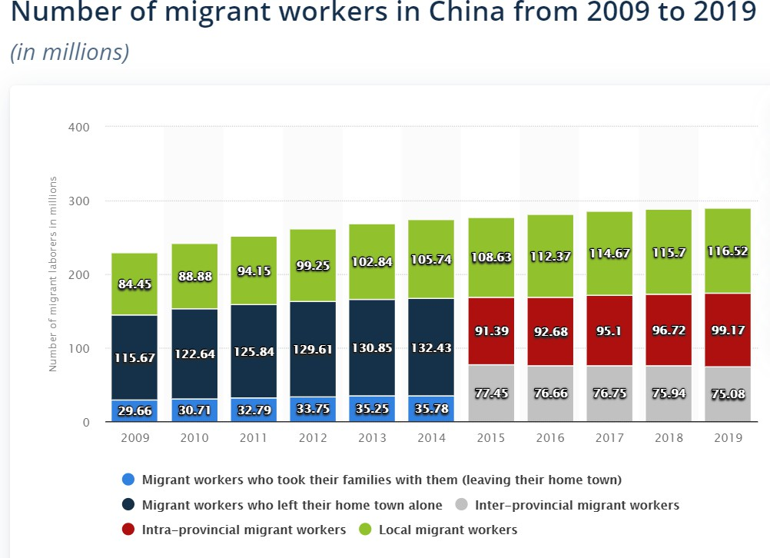
(https://www.statista.com)

The gross domestic products’ annual growth rate is remaining around 7% in the last five years, however, in the first quarter of 2020, it dropped to -7% and rose to 3% in the second quarter of 2020. (China, GDP Annual growth rate, https://tradingeconomics.com/,) From Chinese history, from 1978, China adopted the open door economy policy to attract domestic private funds foreign investments. (Bamber, 2016, p.293) From the result of Csanadi’s (2016) research, China follows neither liberal market economies (LME) nor coordinated market economies (CME). China is a communist system that is identified from a monopoly political power network, the state, and the economy, levels of aggregation while decentralized power network with pattern- conforming instruments of resource extraction and distribution. (Csanadi, 2016) Yan (2018) explained that China has both features of liberal and coordinated market economies that have their Chinese values. Chinese role of government involves two kinds of market economies features, foreign direct investments, and other international relations and monopoly political power illustrates a mixture of varieties of capitalisms. As a result, China is the best innovator in emerging economies and the largest population in the world. (Corness University et al., 2019 as cited in Zhu et al., 2020) Innovation and employment have a positive relationship that when the way to produce something is changed, it requires different skills and workers. (Zhu et al., 2020) Also, Chinese innovative assessments and broad vision attract foreign investors that China became one of the world’s leading countries in terms of foreign direct investments.
To compare the United States and China’s varieties of capitalism, the United States has a liberal market economy that allows producing any products and services while China has a mixture of liberal and coordinated market economies that creates national values. The number of migrant workers is consists of 20% of the workforce in China, 26% of the workforce in the United States. The gross domestic product annual growth rate trend is almost the same in both countries, but the average of last five years was 7% in China, 5% in the United States and the change of Corona Virus in GDP’s growth rate in 2020 is first two quarters have declining

statistics in the United States and the Chine has risen in the second quarter of 2020. China and the United States are leading countries in terms of innovation, but the foreign direct investment might be more in China.

Unionization
The union is the organization that aims to be the voice of employees by solving workplace-related issues, and law breaches in the workplace. Deery et al., (2014) found out that member of union increases the externalities of the working firm, as a result of that it creates improvement in the effectiveness of the organization. Also, the union is one of the vital parties in every nation’s employment relation system. In the United States’ Union history, skilled craftsmen formed a national Union in 1860 and 6 years later the craft union organized on a national basis into a central organization. (Bamber, 2016, p.50) In the United States employment relation system history, there are several parties participated such as national union, scientific management (Taylorism), and organization (The American Federation of Labour-Congress of Industrial Organizations). Even though unions are in the rebellion and downturn such as during the World Wars and the time that anti-union propaganda, it is still considered as a major party of the employment system. To the United States Bureau of Labor Statistics, from 1983 to 2018 which is in 35 years, union members declined 20.1% to 10.5% of overall workers.

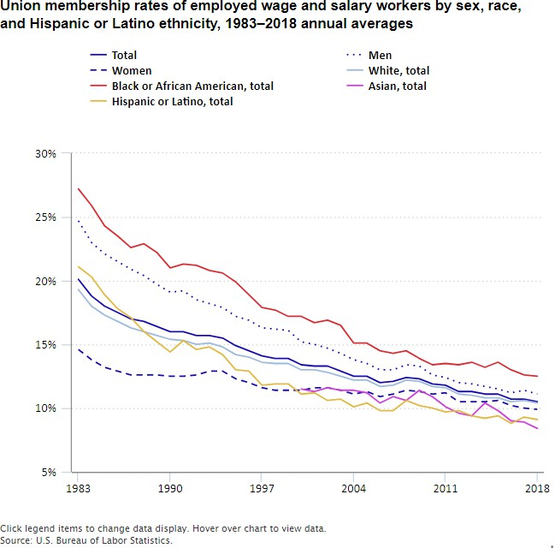
(U.S. Bureau of Labor Statistics)

Also, Union membership statistics of 2019, the membership dropped to 10.3 which is 0.2% less than in previous years. (U.S. Bureau of Labor Statistics, Union members-2019) Also, it is identified that out of 10.3% of Union members, 33.6% of members are from the public sector, 6.2% from private-sector workers. (U.S. Bureau of Labor Statistics, Union members-2019) One of the key considerations of the Union is the salary and wage of the workforce. Gittleman and Kleiner (2016) demonstrated that not the only economic return of Union is greater than licensing coverage but also Union reduces wage inequality in the United States. In addition, the macro effect of unionized firms’ wage is 15-20% more than non-unionized firms. (Gittleman and Kleiner, 2016) Ahlquist and Downey (2019) explained that due to Chinese imported products, American manufacturing unionized workers declined. Also, the United States union density can be 36% larger than today’s statistic without the import of China. (Ahlquist and Downey, 2019) However, Meszaros (2018) argued that Union density has a negative impact on income inequality in the United States employment relation system in terms of compress middle income and decrease the discrepancy between top earners and lower levels of the income

distribution. Similarly, Jaumotte and Osorio Buitron (2020) illustrated that there is a negative relationship between the power of union and top income shares.
Chinese employment relation system has one union that is the All-China Federation of Trade Unions (ACFTU) and it is founded in 1925. (Bamber, 2016, p.300) Also, ACFTU is the largest union federation in the world by its number of memberships. The working process of ACFTU is tied under the Trade Union Law, Labor Law, and Labor Contract Law of China. (Bamber, 2016, p.301) In 2012, The All-China Federation of Trade Union has 280 million members and union density was 80.1%. (Qi and Huang, 2017) In 2018, the member of the Union is 273.1 million which is dropped statistics from the previous year, although, in the last 8 years, the membership is remaining around 270 million. (China Statistical Yearbook, 2019, https:stats.gov. cn) However, In 2015 Chinese union density rate declined to 44.9% that 35.2% of union density is diminished within three years. (https://ilostat.ilo.org/topics/union-membership/) There is a trend of upturns and a downturn in the Chinese union history. One of the biggest upturns in Chinese union density history between 2000-2010 that density is increased by 30.4% while most of the developed countries having a declining trend in the union densities. (Qi and Huang, 2017, ) Huang et al., (2020) found out that Chinese union commitment has a positive relationship with employee work performance and participation. Contrarily, even though Union aims to become the voice of the labor market and make a solution for workplace issues, Fan et al., (2018) research results show Chinese unions cannot significantly influence labor conflicts. Also, there is a positive relationship between unions and labor conflicts that might be explained that is because of only one union that creates monopoly power and a lack of voice mechanism. (Fan et al., 2018) Rong et al., (2020) noted that China attracts foreign direct investments by their innovative assessment, broad vision and China became the world-leading developing country in terms of foreign direct investment in the United Nations Conference, Trade and Development statistics in 1993. Relating to the foreign direct investment, Chan et al., (2017) noted that Chinese union stabilizing the workplace and reducing labor turnover in enterprises. Oppositely, Yang, and Tsou (2018) demonstrated that union has a negative effect on both labor and factor productivity in foreign- owned enterprises and private firms.
Evaluating the Unions and the memberships, trends of the United States, and China, the Chinese Union is founded in 58 years earlier than the United States’ union. Hence, several unions are operating in U.S history while China has only one powerful union in their employment relation system. Comparing the density of union, the U.S has much less than China that 10.5% and 78.1%. (U.S. Bureau of Labor Statistics, Appendice#8, 9 and Qi, Huang, 2017) China and the U.S employment relation system’s union trend have both downturns and upturns. However, China is having a higher union density in the last decades of union history. (Qi and Huang, 2017, Appendice#7) In terms of the effectiveness of the Unions of the U.S and China, there are diversified researches and conclusions found in both negative and positive effects identified. Therefore, it is not possible to compare and contrast the efficiency of two countries’ unions.

Corona Virus
In late 2019, Corona Virus is started spread throughout the world. Due to the Corona Virus, pandemic situation, some major changes occurred in terms of work and the labor market. (Markey and Ray, 2020) One of the notable changes that happened in the labor market is the increased rate of unemployment. According to the bureau statistics of the United States, the highest average rate of unemployment was 5.3% in 2015 and the lowest is 3.7% of the overall population over 16 in 2019 the last five years. Also, since 2015, the unemployment rate is steadily decreasing year by year. However, the average of the first 8 months of 2020 unemployment rate is 8.7% and the highest was in April 14.7% that dramatically increased by 10.3% from March 2020. (U.S. Bureau of Labor Statistics, LNS14000000) Therefore, relating to the dramatic growth of the unemployment rate in the United States, it is clear that the pandemic situation is not only affecting the employment but also the economy of the nation. To stop the spread of the Virus, every nation implements the rules and restrictions depending on the transmission type and the number of new cases. United States of America’s total Corona Virus affected case is 7,043,000 and reached the highest cases and deaths, out of 31.4 million cases found throughout the world. (http://www.worldmeters.info) Based on the number of Corona virus affected cases are increasing, the United States government adopted social distancing measures. Social distancing measures included bans on large social gatherings; school closures; closures of entertainment venues, gyms, bars, and restaurant dining areas; and shelter-in-place orders. (Courtemanche et al., 2020) In

addition, the government suggested the social distancing meter of each person is 2 meters which is different in several countries. (Xie et al., 2020) Fairlie et al., (2020) demonstrated that social distancing related rules and regulations on the timetable or shutdowns are the reason for risen unemployment. Therefore, the United States Government structured some stimulus package which is a tangible way to rescue from the Corona Virus for the employees. The United States of America is one of the three countries out of G7 countries that implemented a stimulus package to one side support the economy of the nation, on the other side to solve unemployment-related issues. (Narayan et al., 2020) Megginson and Fotak (2020) noted that most of the spending of stimulus packages into employer and employee. Out of the stimulus packages, 250 billion dollars planned to spend for the existing Unemployment Insurance benefit with a supplement $600 every week within CARES Act. (Megginson and Fotak, 2020) Casado et al., (2020) found out that when unemployment increased by 1%, the consumer spending index dropped by 6%, while an increase of 1% of replacement rate leads to an increase spending index more 0.5%. (Appendice#10) The replacement rate is depending on how many people get benefits. However, unemployment insurance benefits increased the consumer spending index by 0.5% when the unemployment rate increased by 1% that helps to support the nation’s economy. Also, Kaspers et al., (2020) demonstrated that the effectiveness score that is measured as economic stimulus spending (percent GDP) divided by the unemployment rate change of stimulus package is around 2% while income support is at the same level. (Kaspers et al., 2020)
However, China especially Wuhan city is the pandemic’s first epicenter that having lockdown from January 2020. Each countries state is implementing different lockdown strategies depending on the transmission types and cases. The Wuhan city which is the first city of China that has a first Coronavirus identified was implementing such strict lockdown that shuttered the airport, highways, and train stations, closed most businesses, suspended public transit (subways, buses, and taxis), banned private cars, and ordered everybody not to leave their apartment except for medical emergencies. (Ren, 2020) Also, the Chinese government suggested social distancing space is more than 1 meter from others. (Xie et al., 2020) Oxford analysts found out that there is a positive interaction between lockdown and unemployment rate. (Oxford Analytica, 2020) From the lockdown started implementing in China, the unemployment rate is increased 5.2 to 6.3 within one month January to February 2020. (National Bureau of Statistics China) Generally, the Chinese unemployment rate is remaining at around 5.2 from 2018 to 2020. (National Bureau of Statistics China) In the first several months of the Coronavirus infection, the Chinese labor market became unstable and hard to manage due to the rules and restrictions, although the situation and the spread of the Coronavirus are getting managed by now and the unemployment rate is reduced to 5.6 in July. (National Bureau of Statistics China) Chinese government planned 585 billion dollars for the stimulus package that can rescue from the COVID-19 recession. (Allam, 2020) Employment-related supports that the government taking is unemployment financial aid, unemployment insurance benefits, and small and medium-sized enterprises that can return 70% of the paid unemployment insurance contribution if the layoff rate is not higher than 5.5%. (Ban, 2020) From the Kaspers et al., (2020) research, China’s effectiveness score is around 4% while income support is 0.

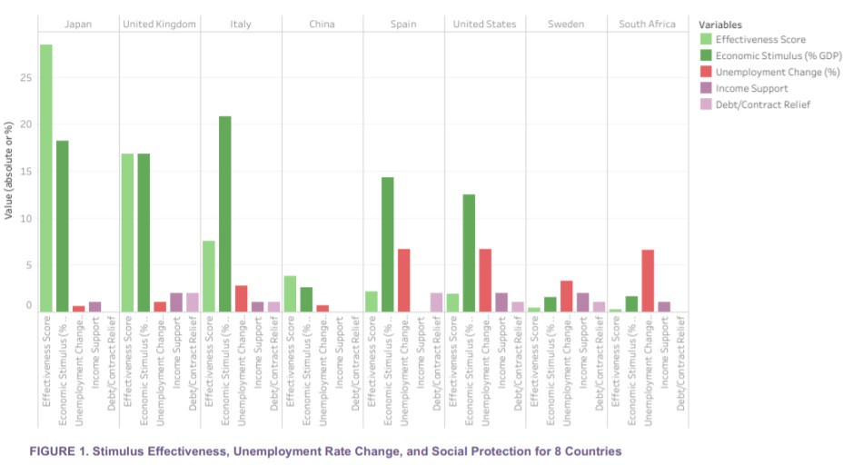
(Kaspers et al., 2020, )

To compare the COVID-19 reaction of the United States change in the highest unemployment rate is increased by 10.3% from before lockdown while the Chinese highest unemployment rate is increased by 1.1%. However, the peaks of the unemployment rate in both countries are different because the transmission and lockdown started at different times. In addition, lockdown rules and restrictions are quite similar in both countries, but the suggested social distancing meter was 2 in the U.S, more than 1 meter in China.
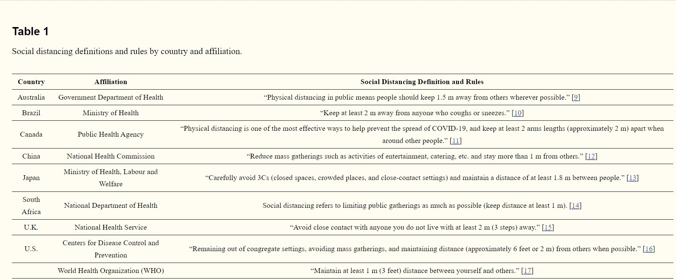
(Xie et al., 2020,)

Moreover, China is in 44th place of overall Coronavirus affected the number of cases in the world while the United States is remaining in the first place. (http://www.worldmeters.info) Generally, government responses to the Corona Virus are quite similar that planned stimulus package that can support the citizens and firms which are in a recession. Nevertheless, the result and the way of spending stimulus packages are slightly different. While the United States government spending most of the stimulus package for the unemployment insurance benefits and unemployed individuals, the Chinese government more likely to get attention to the organizations by returning paid unemployment insurance contributions. Xie et al.,(2020) research identified that the United States’ effectiveness score of the stimulus package and income support are both remaining about 2% while China’s effectiveness score of the stimulus package is around 4% and income support is 0.

Conclusion
The United States and China are both powerful and leading nations in the world. However, the employment relation system and decisions in terms of varieties of capitalism, unionization, impact, and reaction of the Corona Virus are different. The United States has a liberal market economy that gives freedom to choose the products and services to produce while China has not adopted an exact market economy that involves both liberal and coordinated market economy features. Also, China has one powerful union and the United States has several unions in its history. Moreover, the density of the United States union is much less than the Chinese union. Another notable aspect for every nation in the current scenario is the impact and recession of COVID-19. Generally speaking, rescue from Corona Virus impacted workers of both government are implementing similar support affected people that planned stimulus package. However, the way to spend the stimulus package is different. Most of the stimulus package of the United States is to unemployed individuals that benefit from unemployment insurance while the Chinese government gives more attention to the organizations to remain the workers and get the refund of paid unemployment insurance contributions.

REFERENCES
Ahlquist, J. S., & Downey, M. (2019). Import Exposure and Unionization in the United States. Working paper, UC San Diego Center for Commerce and Diplomacy.
Allam, Z. (2020). Vital COVID-19 Economic Stimulus Packages Pose a Challenge for Long-Term Environmental Sustainability. Surveying the Covid-19 Pandemic and its Implications, 97.

Bamber, G. (2016). International and Comparative Employment Relations: National Regulation, Global Changes. (6th ed.).
Ban, X. (2020). Responding to the Impact of COVID-19 on Labor Relationship in China. Noticias CIELO, 7.
Bernstein, S., Diamond, R., McQuade, T., & Pousada, B. (2018). The contribution of high-skilled immigrants to innovation in the United States (No. 3748).
Casado, M. G., Glennon, B., Lane, J., McQuown, D., Rich, D., & Weinberg, B. A. (2020). The Effect of Fiscal Stimulus: Evidence from COVID-19 (No. w27576). National Bureau of Economic Research.
Chan, A. W., Snape, E., Luo, M. S., & Zhai, Y. (2017). The developing role of unions in China’s foreign‐
invested enterprises. British Journal of Industrial
Courtemanche, C., Garuccio, J., Le, A., Pinkston, J., & Yelowitz, A. (2020). Strong Social Distancing Measures In The United States Reduced The COVID-19 Growth Rate: Study evaluates the impact of social distancing measures on the growth rate of confirmed COVID-19 cases across the United States. Health Affairs, 10-1377.
Csanadi, M. (2016). China in between Varieties of Capitalism and Communism.
Dibben, P., & Williams, C. (2012). Varieties of Capitalism and Employment Relations: Informally Dominated Market Economies. Industrial Relations: A Journal of Economy and Society, 51(Supp.1), 563-582.
Fairlie, R. W., Couch, K., & Xu, H. (2020). The impacts of covid-19 on minority unemployment: First evidence from april 2020 cps microdata (No. w27246). National Bureau of Economic Research.
Fan, H., Dong, Y., Hu, D., & Luo, L. (2018). Do labour unions mitigate labour conflicts in China’s manufacturing firms?. International Journal of Conflict Management.
Feldmann, M. (2019). Global Varieties of Capitalism. World Politics, 71(1), 162-196.
Gittleman, M., & Kleiner, M. M. (2016). Wage effects of unionization and occupational licensing
coverage in the United States. ILR Review, 69(1), 142-172.
Hou, J., Huang, C., Licht, G., Mairesse, J., Mohnen, P., Mulkay, B., . . . Zhen, F. (2019). Does innovation stimulate employment? Evidence from China, France, Germany, and The Netherlands. Industrial and Corporate Change, 28(1), 109-121
Huang, W., Yuan, C., Shen, J., & Li, M. (2020). Effects of union commitment on job performance in
China. Personnel Review.
Jaumotte, F., & Osorio Buitron, C. (2020). Inequality: Traditional drivers and the role of union power. Oxford Economic Papers, 72(1), 25-58.
Kaspers, M., Chun, J., & Elkins, K. (2020). COVID-19: Global Trends in Social Protection, Unemployment, and Economic Stimuli.
Mariotti, S., & Marzano, R. (2019). Varieties of capitalism and the internationalization of state-owned enterprises. Journal of International Business Studies, 50(5), 669-691.
Markey, Ray. (2020). The impact of the COVID-19 virus on industrial relations. Journal of australian political economy, (85), 147-154.
Megginson, W. L., & Fotak, V. (2020). Government Equity Investments in Coronavirus Rescues: Why,
How, When?. How, When.
Meszaros, J. (2018). Inequality and unionization within the United States. The Quarterly Review of Economics and Finance, 67, 326-333.
Meyer, M. (2020). Liberalism. In Liberal Democracy (pp. 7-11). Springer, Cham.
Mohseni, M., & Jouzaryan, F. (2016). Examining the effects of inflation and unemployment on economic
growth in Iran (1996-2012). Procedia Economics and Finance, 36, 381-389.
Narayan, P., Phan, D., & Liu, G. (2020). COVID-19 lockdowns, stimulus packages, travel bans, and stock returns. Finance Research Letters, 101732.
Oxford Analytica. Job losses will increase social tension in China. Emerald Expert Briefings, (oxan-db).

Pierre, J. (2015). Varieties of capitalism and varieties of globalization: Comparing patterns of market deregulation. Journal of European Public Policy, 22(7), 908-926.
QI, D., & HUANG, J. (2017). Chinese Trade Unions: Development and Dilemmas. In GOVERNING SOCIETY IN CONTEMPORARY CHINA (pp. 75-90).
Relations, 55(3), 602-625.
Ren, X. (2020). Pandemic and lockdown: a territorial approach to COVID-19 in China, Italy and the United States. Eurasian Geography and Economics, 1-12.
Rong, S., Liu, K., Huang, S., & Zhang, Q. (2020). FDI, labor market flexibility and employment in
China. China Economic Review, 101449.
Witt, M. A., & Jackson, G. (2016). Varieties of capitalism and institutional comparative advantage: A test and reinterpretation. Journal of International Business Studies, 47(7), 778-806.
Xie, K., Liang, B., Dulebenets, M. A., & Mei, Y. (2020). The Impact of Risk Perception on Social Distancing during the COVID-19 Pandemic in China. International Journal of Environmental Research and Public Health, 17(17), 6256.
Yan, X. (2018). Chinese values vs. liberalism: what ideology will shape the international normative
order?. The Chinese Journal of International Politics, 11(1), 1-22.
Yang, C. H., & Tsou, M. W. (2018). Labour Unions and Firm Productivity: Evidence from China. The Manchester School, 86(6), 699-721.
Zhu, C., Qiu, Z., & Liu, F. (2020). Does innovation stimulate employment? Evidence from China. Economic Modelling.

